EX No : 2 | EXPLORATORY DATA ANALYSIS - DATA IMPORT AND EXPORT

Aim
To analyze the Sales Data Analysis dataset using Exploratory Data Analysis (EDA), identify important sales patterns, calculate sales value, visualize product and city performance, build a machine learning model to predict sales, evaluate the model, and export the processed data to Excel.
Dataset Overview
Dataset file: 9. Sales-Data-Analysis(1).csv
Dataset shape: 254 rows × 10 columns
Columns: Order ID, Date, Product, Price, Quantity, Purchase Type, Payment Method, Manager, City, Sales
Derived target variable: Sales = Price × Quantity
Total Sales: 769,515.86
Average Sales per order: 3,029.59
Procedure
1. Load the Sales Data Analysis dataset using Pandas.
2. Display the first few records, shape, information, and missing values.
3. Convert the Date column into datetime format.
4. Check and handle missing values.
5. Create a Sales column using Price × Quantity.
6. Perform EDA using descriptive statistics and sales distributions.
7. Analyze sales by Product and City.
8. Prepare numerical and categorical features for machine learning.
9. Split the dataset into training and testing data.
10. Train a Random Forest Regression model to predict Sales.
11. Predict sales for the test dataset.
12. Evaluate the model using MAE, RMSE, and R² score.
13. Export the processed dataset to Excel.
Python Code
import pandas as pd
import numpy as np
import matplotlib.pyplot as plt
from sklearn.model_selection import train_test_split
from sklearn.compose import ColumnTransformer
from sklearn.preprocessing import OneHotEncoder
from sklearn.pipeline import Pipeline
from sklearn.impute import SimpleImputer
from sklearn.ensemble import RandomForestRegressor
from sklearn.metrics import mean_absolute_error, mean_squared_error, r2_score

# 1. Load dataset
df = pd.read_csv("9. Sales-Data-Analysis(1).csv")

# 2. Display data and information
print(df.head())
print(df.shape)
print(df.info())
print(df.isnull().sum())

# 3. Convert Date
df["Date"] = pd.to_datetime(df["Date"], dayfirst=True)

# 4. Create Sales target
df["Sales"] = df["Price"] * df["Quantity"]

# 5. EDA
print(df.describe())
print(df.groupby("Product")["Sales"].sum().sort_values(ascending=False))
print(df.groupby("City")["Sales"].sum().sort_values(ascending=False))

# 6. Visualization
df.groupby("Product")["Sales"].sum().sort_values(ascending=False).plot(kind="bar")
plt.title("Total Sales by Product")
plt.xlabel("Product")
plt.ylabel("Sales")
plt.xticks(rotation=35)
plt.show()

df.groupby("City")["Sales"].sum().sort_values(ascending=False).plot(kind="bar")
plt.title("Total Sales by City")
plt.xlabel("City")
plt.ylabel("Sales")
plt.xticks(rotation=35)
plt.show()

# 7. Date features
df["Year"] = df["Date"].dt.year
df["Month"] = df["Date"].dt.month
df["Day"] = df["Date"].dt.day

# 8. Features and target
X = df.drop(columns=["Sales", "Date", "Order ID"])
y = df["Sales"]

num_cols = X.select_dtypes(include=np.number).columns.tolist()
cat_cols = X.select_dtypes(exclude=np.number).columns.tolist()

# 9. Preprocessing
preprocessor = ColumnTransformer([
("num", SimpleImputer(strategy="median"), num_cols),
("cat", Pipeline([
("imputer", SimpleImputer(strategy="most_frequent")),
("onehot", OneHotEncoder(handle_unknown="ignore"))
]), cat_cols)
])

# 10. Random Forest Regression
model = Pipeline([
("preprocessor", preprocessor),
("regressor", RandomForestRegressor(
n_estimators=200, random_state=42
))
])

# 11. Train-test split
X_train, X_test, y_train, y_test = train_test_split(
X, y, test_size=0.2, random_state=42
)

# 12. Train
model.fit(X_train, y_train)

# 13. Predict
y_pred = model.predict(X_test)

# 14. Evaluation
mae = mean_absolute_error(y_test, y_pred)
rmse = np.sqrt(mean_squared_error(y_test, y_pred))
r2 = r2_score(y_test, y_pred)

print("MAE:", mae)
print("RMSE:", rmse)
print("R2 Score:", r2)

# 15. Export
df.to_excel("Sales_Data_Analysis_Processed.xlsx", index=False)
print("Analysis completed!")

Output
First five records:
Order ID | Date | Product | Price | Quantity | Purchase Type | Payment Method | Manager | City
10452 | 2022-11-07 00:00:00 | Fries | 3.49 | 573.07 | Online | Gift Card | Tom Jackson | London
10453 | 2022-11-07 00:00:00 | Beverages | 2.95 | 745.76 | Online | Gift Card | Pablo Perez | Madrid
10454 | 2022-11-07 00:00:00 | Sides & Other | 4.99 | 200.4 | In-store | Gift Card | Joao Silva | Lisbon
10455 | 2022-11-08 00:00:00 | Burgers | 12.99 | 569.67 | In-store | Credit Card | Walter Muller | Berlin
10456 | 2022-11-08 00:00:00 | Chicken Sandwiches | 9.95 | 201.01 | In-store | Credit Card | Walter Muller | Berlin
Dataset Shape: (254, 10)
Missing Values: No missing values were found in the supplied dataset.
Total Sales: 769,515.86
Minimum Sales: 1,000.00
Maximum Sales: 16,074.43
EDA Results
Highest total sales by product: Burgers (376,999.81)
Highest total sales by city: Lisbon (241,714.12)
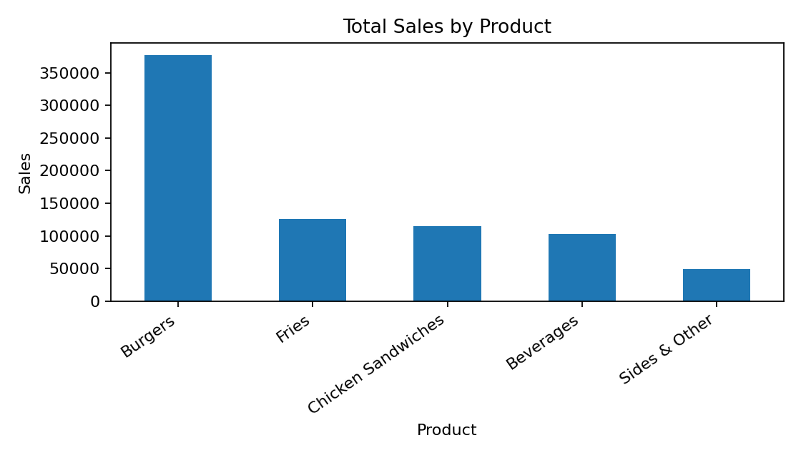
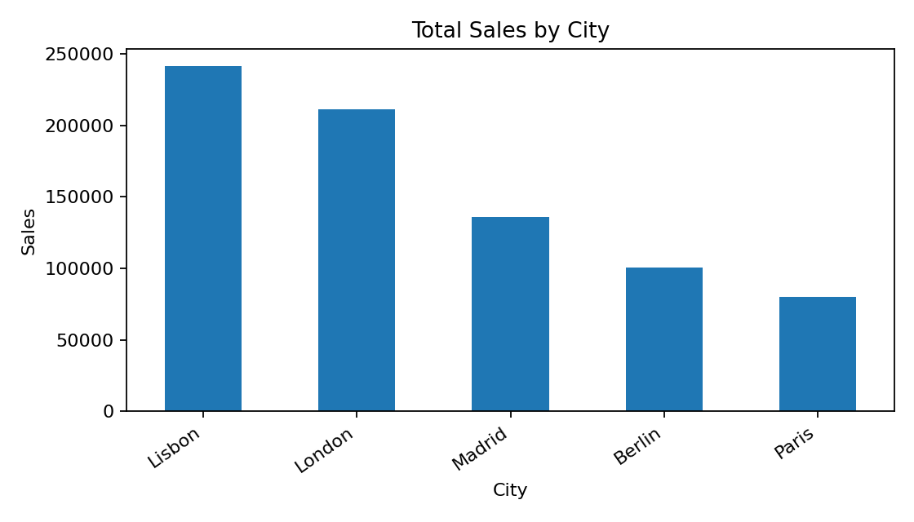
Model Evaluation
Training records: 203
Testing records: 51
MAE: 37.4321
RMSE: 95.7656
R² Score: 0.9983
Result
The Sales Data Analysis dataset was successfully imported, explored, processed, and modeled. The dataset contains 254 records and 9 original fields. A Sales target was derived as Price × Quantity. EDA identified Burgers as the highest-sales product and Lisbon as the highest-sales city. A Random Forest Regression model was trained and achieved an R² score of 0.9983 on the test data. The processed dataset was exported successfully to Sales_Data_Analysis_Processed.xlsx.

